LABORATORY OBSERVATION/RECORD
Course: Full Stack Web Development
Course Code: 23CM4121
Task No.: 2
Student Name: EMANDI HARI CHARAN
Roll No.: A24126552080
Date: 31-07-2026

OBSERVATION TASK 2: HTML5 CANVAS GRAPHICS AND CSS3 WEB PAGE STYLING

PART A: HTML5 Canvas 2D Graphics Drawing
Task Requirement:
Develop an HTML5 Canvas program using JavaScript 2D context to render a blue rectangle, a red circle, a green stroke line, and text displaying student name ('Hari Charan').
part_A.html
<!DOCTYPE html>
<html lang="en">
<head>
<meta charset="UTF-8">
<meta name="viewport" content="width=device-width, initial-scale=1.0">
<title>HTML5 Canvas</title>
</head>
<body>
<!-- ================= PART A: HTML5 CANVAS ================= -->
<section id="canvas" class="canvas-section">
<h2>HTML5 Canvas</h2>
<canvas id="myCanvas" width="700" height="300">
Your browser does not support the HTML5 Canvas.
</canvas>
</section>
<script>
/* Get Canvas */
const canvas = document.getElementById("myCanvas");
const ctx = canvas.getContext("2d");
/* Rectangle */
ctx.fillStyle = "blue";
ctx.fillRect(40, 40, 150, 90);
/* Circle */
ctx.beginPath();
ctx.arc(300, 85, 45, 0, 2 * Math.PI);
ctx.fillStyle = "red";
ctx.fill();
/* Line */
ctx.beginPath();
ctx.moveTo(420, 40);
ctx.lineTo(620, 140);
ctx.strokeStyle = "green";
ctx.lineWidth = 5;
ctx.stroke();
/* Display Name */
ctx.font = "30px Arial";
ctx.fillStyle = "black";
ctx.fillText("Hari Charan", 220, 240);
</script>
</body>
</html>

Actual Output Screenshot - Part A:
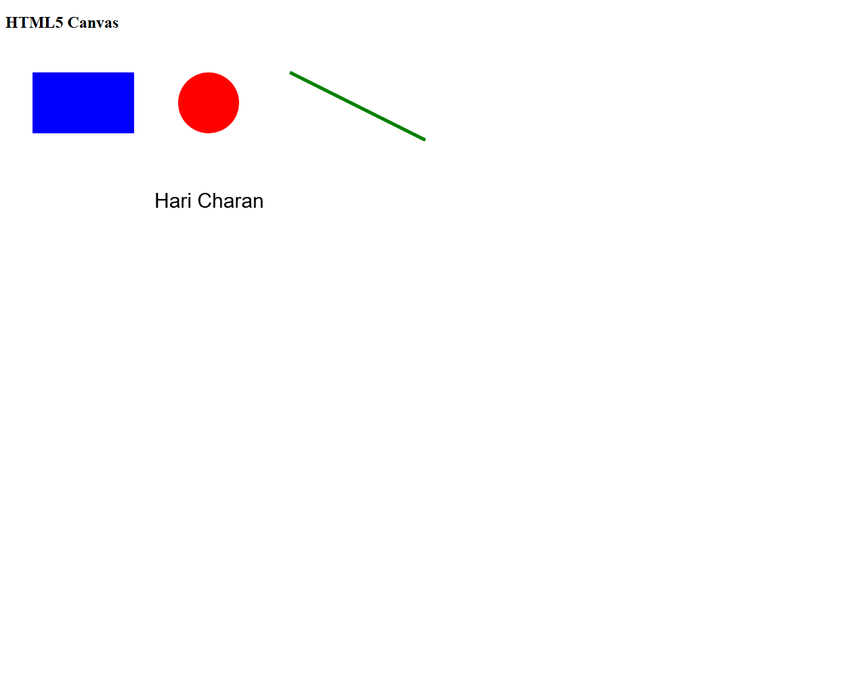

Result: Part A was executed and verified successfully. HTML5 Canvas context rendered the blue rectangle, red circle, green line, and student name text 'Hari Charan'.

PART B: My Styled Webpage - CSS3 Layout, Cards & Gradients
Task Requirement:
Design a styled webpage titled 'My Styled Webpage' featuring a CSS3 linear gradient background, dark header with text shadow, navigation bar with hover effects, three flexbox content cards (HTML5, CSS3, Canvas) with shadows and hover buttons, and a footer.
part_B.html
<!DOCTYPE html>
<html lang="en">
<head>
<meta charset="UTF-8">
<meta name="viewport" content="width=device-width, initial-scale=1.0">
<title>My Styled Webpage</title>
<style>
/* General Styling */
body {
margin: 0;
font-family: Arial, Helvetica, sans-serif;
background: linear-gradient(to right, #74ebd5, #ACB6E5);
}
/* Header */
header {
background: #0d47a1;
color: white;
text-align: center;
padding: 20px;
text-shadow: 2px 2px 5px black;
}
header h1 {
margin: 0;
font-size: 40px;
}
/* Navigation */
nav {
background: #333;
text-align: center;
padding: 15px;
}
nav a {
color: white;
text-decoration: none;
margin: 20px;
padding: 10px 15px;
font-size: 18px;
}
nav a:hover {
background: orange;
border-radius: 5px;
}
/* Cards */
.cards {
display: flex;
justify-content: center;
gap: 25px;
margin: 40px;
flex-wrap: wrap;
}
.card {
width: 280px;
background: white;
border: 2px solid #0d47a1;
border-radius: 15px;
padding: 20px;
box-shadow: 5px 5px 15px gray;
text-align: center;
display: flex;
flex-direction: column;
}
.card h3 {
color: #0d47a1;
}
.card p {
font-size: 16px;
line-height: 1.5;
}
/* Button */
button {
background: #1976d2;
color: white;
border: none;
padding: 10px 20px;
border-radius: 8px;
cursor: pointer;
font-size: 16px;
}
button:hover {
background: green;
}
/* Footer */
footer {
background: #222;
color: white;
text-align: center;
padding: 20px;
margin-top: 30px;
}
</style>
</head>
<body>
<!-- ================= PART B: HEADER ================= -->
<header id="home">
<h1>My Styled Webpage</h1>
<p>HTML5 Graphics and CSS3 Web Styling</p>
</header>
<!-- ================= NAVIGATION ================= -->
<nav>
<a href="#home">Home</a>
<a href="#cards">Cards</a>
<a href="#footer">Footer</a>
</nav>
<!-- ================= THREE CONTENT CARDS ================= -->
<section id="cards" class="cards">
<!-- Card 1 -->
<div class="card">
<h3>HTML5</h3>
<p>
HTML5 introduces semantic elements, multimedia support,
and the Canvas element for creating graphics.
</p>
<button>Learn More</button>
</div>
<!-- Card 2 -->
<div class="card">
<h3>CSS3</h3>
<p>
CSS3 enhances webpages using gradients, borders,
rounded corners, shadows and hover effects.
</p>
<button>Explore</button>
</div>
<!-- Card 3 -->
<div class="card">
<h3>Canvas</h3>
<p>
HTML5 Canvas allows drawing graphics such as
rectangles, circles, lines and text using JavaScript.
</p>
<button>View Demo</button>
</div>
</section>
<!-- ================= FOOTER ================= -->
<footer id="footer">
<p>
© 2026 My Styled Webpage | HTML5 & CSS3 Laboratory
</p>
</footer>
</body>
</html>

Actual Output Screenshot - Part B:
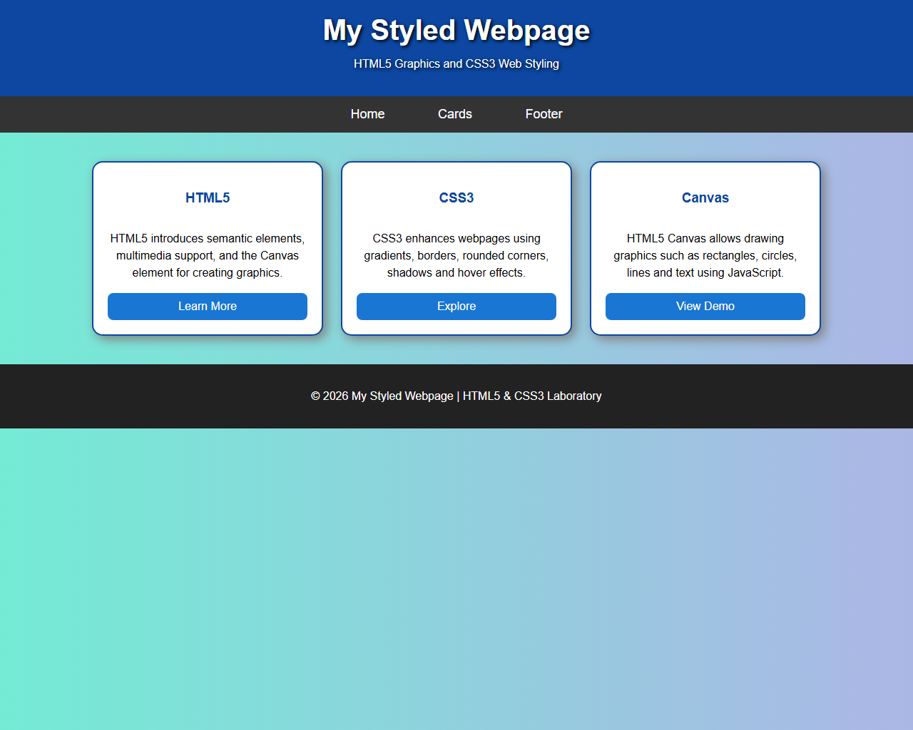
Result: Part B was executed and verified successfully. The webpage renders linear gradient background, styled header, flexbox content cards with box-shadow depth, and styled footer.

